Atelier Bloom
Create a Web page (HTML5 + CSS3 + images) that looks and behaves like the screenshot below:
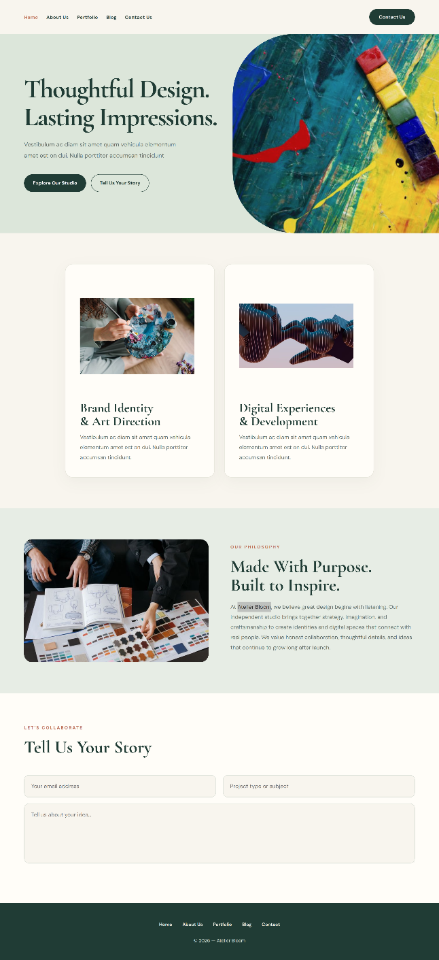
You are given the above screenshots + all required images.

Output
The output should be valid HTML5 + CSS3 + images that implement the above web page.

Constraints
- Use font 'Cormorant Garamond' for the text and font 'sans-serif' for the buttons – (https://fonts.googleapis.com/css2?family=Cormorant+Garamond:wght@500;600;700&family=DM+Sans:wght@400;500;600;700&display=swap)
- The site should open correctly in the latest version of Chrome

